Passenger Itinerary for MOOSE, BILLY,
Please print/retain this page for your records. Thank you for choosing North Star Air.
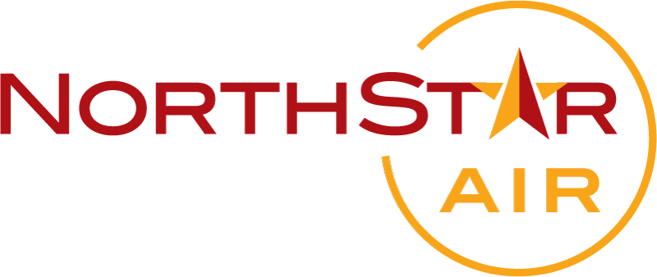 | Customer Care  Toll Free: 1-844-633-6294  1-807-474-2896  reservations@northstarair.ca
Passenger  Name: MOOSE, BILLY,  Phone #: 807 773-5240 (Martina)  Contact  Name: COMBER, LENARD  Form of Payment: VISA-INTG     8578  PO: | Booking Information  - Booking Reference/Locator#: 751614  - Booked On: 04/14/2022 13:30

Flight Information
FLIGHT | FROM | TO | DEPART | ARRIVE | STATUS | FARE BASIS | FARE
130 | SIOUX LOOKOUT (YXL) | POPLAR HILL (PV7) | 04/22/2022 04/22/2022 14:30 | 04/22/2022 15:40 | CONFIRMED | Thrift | 279.54

Fare Summary
Fare | $279.54
Taxes, Fees and Charges
Nav Canada Surcharge | $0.00
AIF/ATSC | $4.87
Other Charges | $28.69
Subtotal | $313.10
GST/HST | $40.70
Total - CAD | $353.80
Balance Due | $0.00

Notes
Terms and Condition
Terms and Conditions
Thank you for choosing North Star Air (hereinafter referred to as NSA). We look forward to welcoming you onboard!
COVID-19 Travel Advisory
Please be advised that due to the developing COVID-19 situation, NSA has implemented pre-travel screening. We recommend you arrive at the airport ad least 60 mintues prior to scheduled departure. For more information please visit http://www.northstarair.ca/covid-19-updates
Approved Travel Required
In order to mitigate the spread of COVID-19 virus, please note that most northern communities have pandemic teams that will need to approve your travel into the community. If you are an essential health care worker booking travel, please identify this in ticket notes. If you are booking online or speaking with our Reservation Agent on the phone, please request to make a note in your reservation. This will still require that you receive permission from a community pandemic team to arrive in their community.
Baggage Allowance
Baggage allowance is 40lbs per fare paying passenger, including Carry-on/Carry-out and Checked Baggage.
Carry-on/Carry-out Baggage
On flights operated by NSA or Summit Air, you may carry with you 1 personal item (max. size: 16 x 33 x 43 cm [6 x 13 x 17 in]) with a weight not exceeding 13lbs. See our complete carry-on baggage policy.
Checked Baggage
Complimentary Allowance: 2 pieces, max weight be bag not exceeding 40lbs, max dimension per bag not exceeding 158.0 cm (62.0 in)
Excess Baggage: Excess baggage charges will apply for additional pieces and overweight baggage and space is subject to availability.
Baggage in excess of 40 pounds will not be accepted as checked baggage and must be shipped as cargo. Freight seats are available for booking to guarantee excess baggage availability. Please call NSA Reservations for more details.
Helpful tip - your first baggage should contain your immediate essentials or your must haves.

Passenger Check-in

Flights Departing Thunder Bay, Sioux Lookout, Red Lake: 90 minutes recommended, 45 minutes cut-off.
Flights Departing All Other Airports: 60 minutes recommended, 30 minutes cut-off.

Failure to respect these deadlines will result in ineligibility for denied boarding compensation. All passengers are required to present one piece of valid government-issued photo identification that shows the holder's name, date of birth and gender at check-in.

Other Terms and Conditions Reservations/Fares

Fares are quoted on a one-way basis that include taxes and fees and are subject to change without notice. Payment is required at the time the reservation is made. Our lowest fares are limited and may not be available on all flights. Some fares may only be available on certain days and times. Promotional fares may have additional fare rules (specified at the time of booking). NSA offers three fare options for passengers: Saver, Thrift and Flex. These options allow you to choose the features that are important to you. Your fare type determines the price, the seats you will be able to access, your baggage allowance and fees. Ask your NSA agent for details at the time of booking. All website fares are subject to change until payment has been completed. Passengers traveling under infant (under the age of 2), children (between the ages of 2 and 11) or senior (ages 65 and older) fares are subject to presenting one piece of positive government issued photo identification. Failure to produce a valid piece of identification may result in a forfeit of the applicable discount.
Change / Cancellation Fees: Change and cancellation policies vary depending on the fare you have purchased. Cancellations of only regular priced fares are refundable. Thrift fares, seat sale fares and discounted fares are non-refundable and non-transferable. No changes can be made within one (1) hour of the scheduled flight and a $25 change fee will apply. Standby seats may be available and require payment to NSA upon boarding. Reservations, itineraries and tickets are non-transferable between passengers. Prices include all taxes and fees.
Special Needs: Please notify NSA Reservations or contact your local agent, prior to booking, if you or any passengers with disabilities require special assistance, so we can make proper arrangements to accommodate. Any passenger who requires assistance will be pre-boarded per flight.
Dangerous Goods: Dangerous goods are articles or substances that are capable of posing a risk to health, safety, property or the environment. Articles and substances that are classified as dangerous goods, except those which are forbidden for transport by air, must be shipped as cargo under special packing requirements and handling procedures. However, some articles/substances may be accepted as carry-on or checked baggage. Please contact an NSA Reservation agent for details or for more details click Transport Canada information on baggage and dangerous goods <<http://www.tc.gc.ca/eng/civilaviation/standards/commerce-dangerousgoods-regoverview-passlugg-menu-1574.htm>>.
Other Articles not Permitted in your Carry-On or Checked Baggage: For a list of these items and other traveler packing tips, please visit <http://www.catsa.gc.ca/complete-item-list> <<http://www.catsa.gc.ca/complete-item-list>>

Air Passenger Protection - Know your Rights
If you are denied boarding, your flight is cancelled or delayed at least two hours, or if your baggage is lost or damaged, you may be entitled to certain standards of treatment and compensation under the Air Passenger Protection Regulations.

Air carriers also publish their tariffs on their websites. The tariff set out terms and conditions of carriage that apply to your travel. You may view these documents online or ask your carrier for a copy.

For more information about your passenger rights, please contact your air carrier, or visit the Canadian Transportation Agency's website.

Please call NSA at 1.844.633.6294 to confirm your reservation within 24 hours prior to your flight time.
Dash-8 Aircrafts Operated by Summit Air
Dash-7 Aircraft Operated by Air Tindi

2014 North Star Air. All rights reserved.

